Call for posters

How to submit a proposal for poster communication
Any communication submission by poster must reach us before:
December 15, 2017

Basic criteria for the presentation of a poster
The posters must be printed in advance and be installed by their authors in the dedicated space, on the first day of the congress from 8.30am to 9am.

Posters should be oriented in portrait format and should not exceed 90 cm wide and 110/120 cm high. You will find below an example of format.
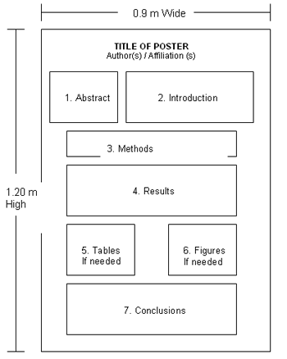
The posters, written in English, must be designed in a graphic manner and be based on clear and simple communication. Please reduce the text to the minimum. The title and text must be large enough to be read from at least two meters away.

To post:
The dimensions must not exceed 90 cm wide by 110-120 cm high;

Display:
Posters will be posted during the conference (2 days).
Authors are requested to install and remove their works according to the following schedule:
- Assembly from 8:30 on January 25, 2018 / Disassembly before 4:30 pm on January 26, 2018
The posters will be exhibited on both days and we ask you to stay close to your poster during the breaks, in order to present them and discuss with the delegates.

Price of the 3 best posters:
The Congress Scientific Committee will elect the 3 best posters to be awarded by a prize. They will be rewarded with three prizes of a respective amount of 1000 € at the gala.

